Assignment 1 (A1):

Information Visualisation

Find references to back up

Review, is it needed?

Worth a re-read – not 100% sure.

Data Set

Chosen data set: Abalone Data Set (<https://archive.ics.uci.edu/ml/datasets/Abalone>)

Data Structure

This data set contains 8 attributes with 4177 instances. There a number of data types, these include: Quantitative; Nominal.

Task to undertake with data

The user wants to be able to guess the age of the abalone, which is determined by the number of rings, that are within it, when it has been cut open. However, this process of cutting open the abalone is time consuming and fiddly.

Create a Design

Prototype 1

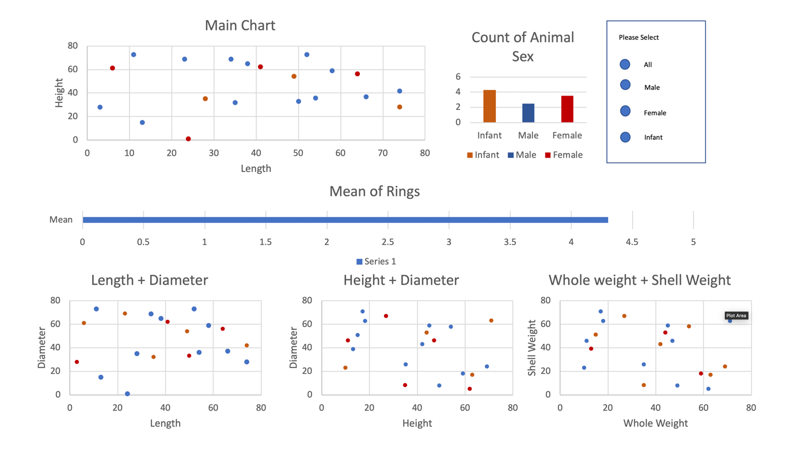

Description and justification:

The starting point for this design is getting a functional, effective system that provides all of the required tasks of the user. [1] So with this in mind the main aim was to make sure that all the required metrics are displayed for the user, to allow them to complete their task as best as possible. Due to humans only being able to deal with things in chunks, I have split the dashboard into vertical sections. Each section has relevant information, which is chunked to make it easier for the user to remember and compare. Also, to try and not overwhelm them with a lot of information in one go. With eyes being better than a person’s memory, having visualisations side-by-side makes it easier to compare [2]. There will be a level of animation, but this will be kept short. This is because it will be used while transitioning between different states [2] when the user has selected a section within the main graph. This subsection is then what will be displayed in the other visualisations, to help get a clearer picture. Scatter charts have been used as they are “Good for showing the relationship between two different variables where one correlates to another (or doesn’t).” [3] An alternative possibility is to use a bubble chart instead as they are good for expressing three numerical variables. [3] Bar charts have been used for the nominal data and the mean of rings. This is because using the categories to separate the values, bar charts allow the user to compare different values when specific values are important, for example, the number of the rings the selected Abalone have [3]. Radio buttons are available to the user to allow them to start filtering out data and see what is more appropriate for completing their task. As if the user has, for example, decided the Abalone is female, then they can remove the noise generated by the male and infant data to allow them to have a clearer picture and make a better decision. The scatter graphs will be placed together at the bottom as they are using similar attributes, which in my initial thoughts I think would have a relative correlation between them. So by them being side by side this will make it easier to compare the values. Each graph will use colours to differentiate the difference between the data points for Male, Female and Infants. This is to allow the user to be able to see the relevant data across all visualisations and know which data point is for what sex. The Hue of the colours will be bold, different colours to make this even easier for the user, as if saturated colours were used, then it means it will make the user have to think and distract away from the task. This, therefore, might make more errors prone to happening. The graphs will also display the data point values when the mouse hovers over the point or column. This is to allow the user to have all the required information they need at their fingertips, with minimal effort on their behalf. Again, this is to allow them to be able to focus on what their actual task is, guessing the age, not figuring out the data values.

** Talk about colours – What type and why- give reference to why colours are good (HUE)

** Hover over labels and labels with in the charts.

Note: Add references and this should be enough (unless from rereading and being concise it makes it too short).

Prototype 2

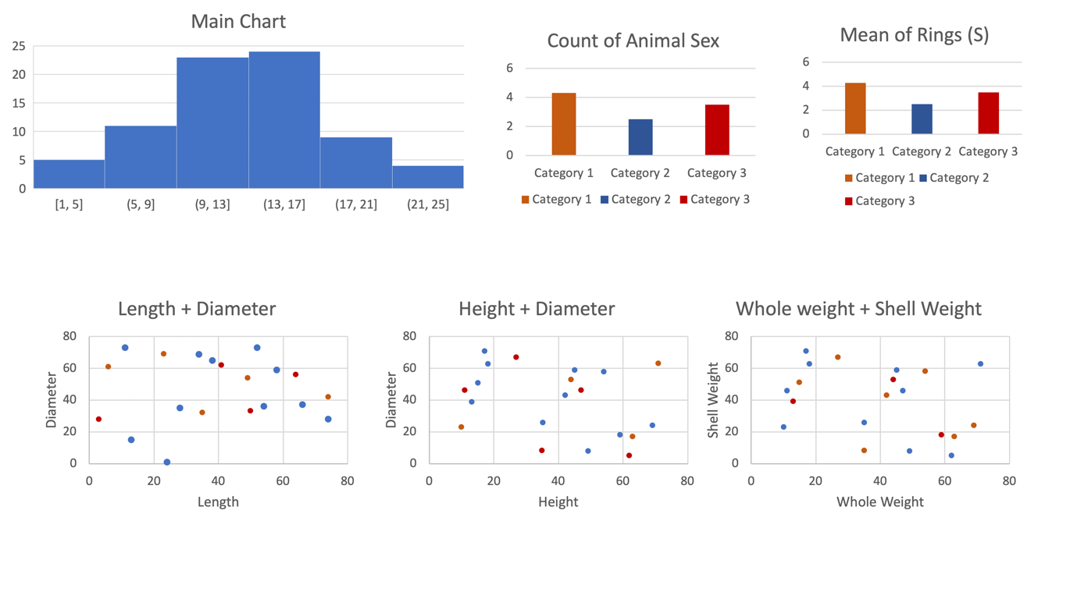

Description and justification: (No references -> must find)

This design is first and foremost aiming to get all the potential measurement required by the user displayed functionally and effectively. The dashboard is presented again in vertical sections. This will have two design sections. A top layer, which will focus on displaying the data within bar charts. This is to allow the user to be able to view different data, with the same process. This is due to the visualisation using the same style, removing unnecessary thinking from the user. (Why using bar charts? Good for comparison?)

The bottom half of the dashboard is using scatter graphs, again to make it easier for the user to keep using the same mindset but displaying different metrics. This is to help give them all the information that they will need to make a judgement on how old the Abalone is without cutting it open. (Why using scatter? Good for analysing?)

All the charts will be linked to the main bar chart, displaying all the relevant information required. This is to filter out any unnecessary data, to make the user be able to do what they need as easily as possible. So all the other bar and scatter graphs will only be displaying information that is linked to the highlighted area in the main bar chart. (Why link data charts together?)

The colours will be using a Hue variance. This is to make sure the data is made clear as possible for the user, as there are three main groups of data or nominal, then this makes it a good feature to set the charts colouring schemes on. (Why using Hue colouring?)

Note: adding in references should make this long enough.

Altair Code Implementation

Data Discoveries

Charts can be cluttered. However, restricting data you don’t get a true result, however, too much data makes it hard to determine.

# Bibliography

**There are no sources in the current document.**

[1] Lecture slides: Visualisation Rule of thumb: Daniel Archambault: 2019, Slide 6

[2] Lecture slides: Visualisation Rule of thumb: Daniel Archambault: 2019, Slide 17

[3] EasyBI - <https://eazybi.com/blog/data_visualization_and_chart_types/> - Accessed [6/11/19]

Ware, Colin – Information Visualisation: Perception for design 3rd edition (year?)

Munzner, Tamara – Visualisation Analysis & Design – 2015

Chen Min, Feixas Miquel, Viola Ivan, Bardera Anton, Shen Han-Wei, Sbert Mateu – Information Theory Tools for Visualisation – 2017

Good link about chunking up data : <https://junkcharts.typepad.com/junk_charts/2013/01/ruining-the-cake-with-too-much-icing.html>